* **JAVASCRIPT :**

1. Difference between null and undefined?

null : An empty or non-existent value. Which assigned to the variable but not represented any value.

Undefined : variable is defined but not assigned any value which results as undefined.

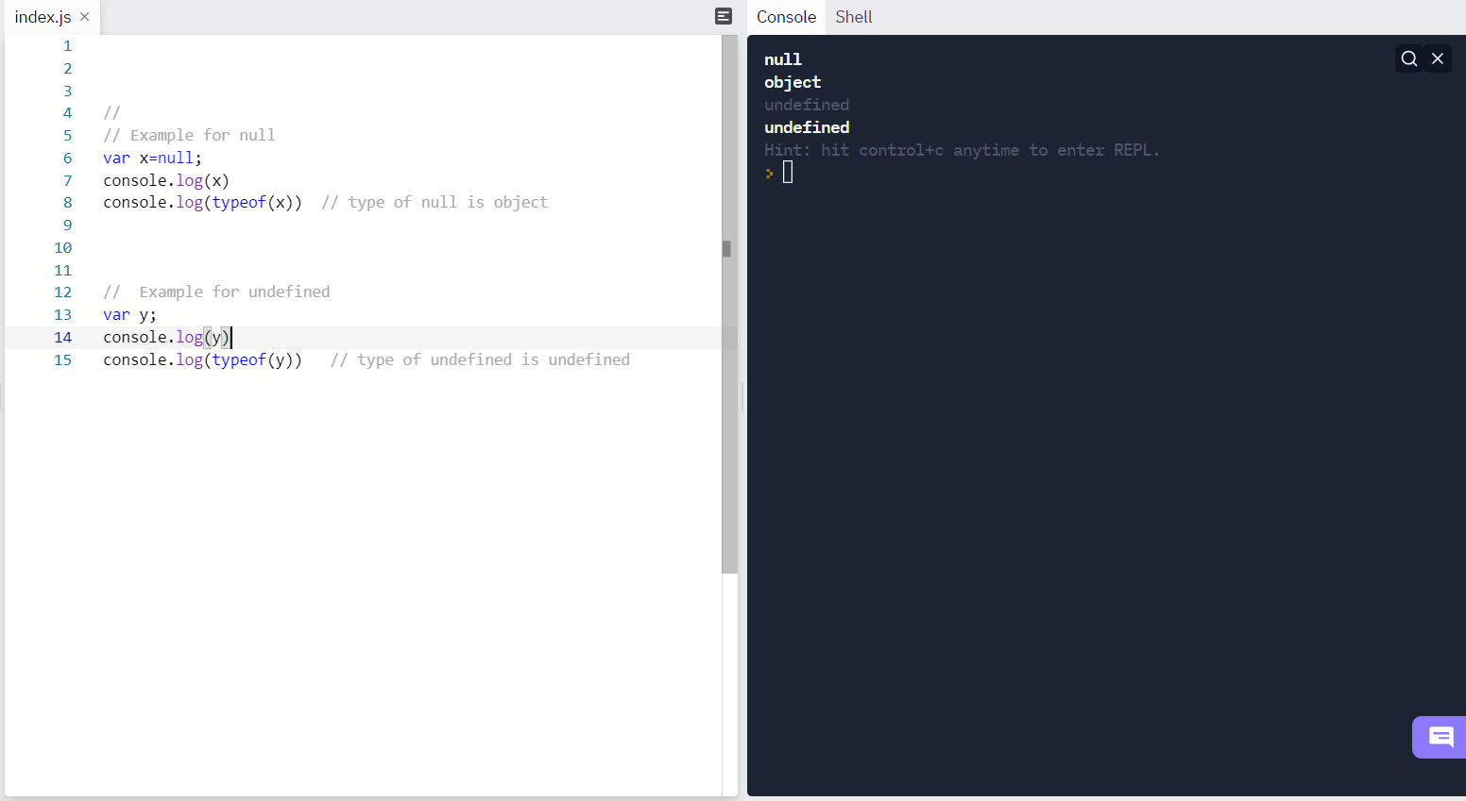

**null VS undefined Difference :**

* data type of null is object and data type of undefined in undefined.
* When used in arithmetic operations, **undefined** will result in **NaN** (not a number), whereas **null** will be converted to **0** behind the screens.
* Null !=== undefined but undefined===null
* Both are falsy values when use in Boolean operations

2) **Promises and callback in JavaScript:**

Promises and callbacks both are use to perform asynchronous operations.

**Callback:** when function is passed as argument to another function is a callback function.

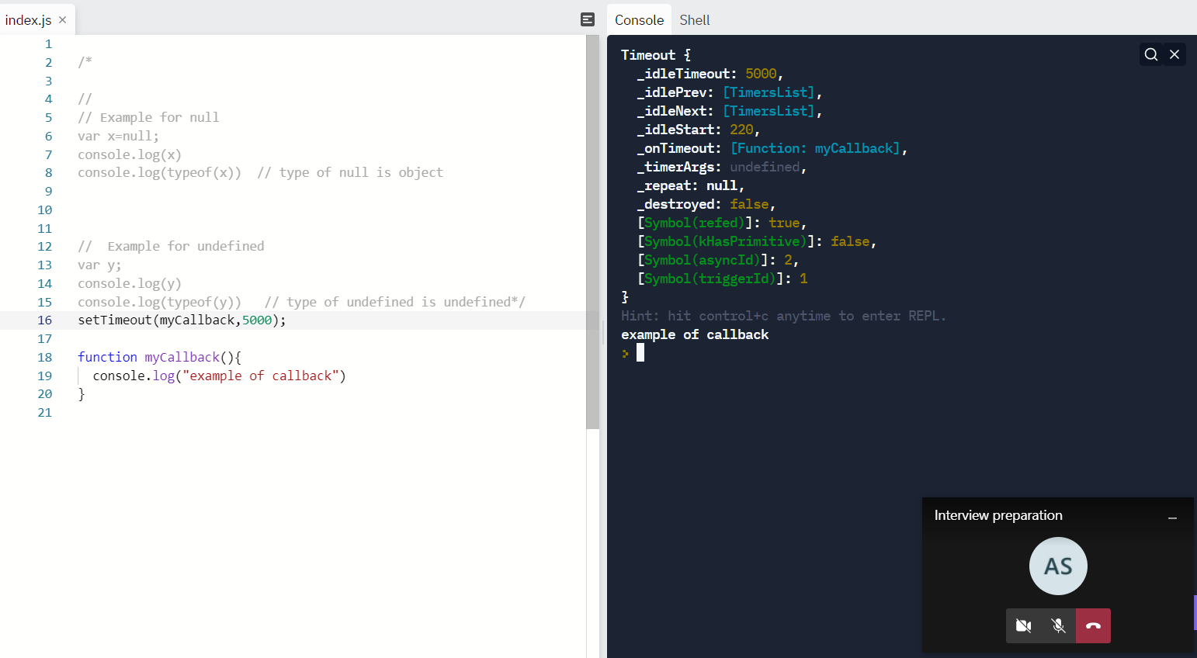

In above code myCallback is passed as argument in setTimeout function.

* To avoid call back hell we prefer to use promises over callback function

**Callback hell :**  nesting of callback is called as callabck hell.